**Experiment : 4.2 Paul Thomas 30 S3 CSB**

**Program**

| class Table{  synchronized void printTable(int n){//synchronized method  for(int i=1;i<=5;i++){  System.out.println(n*i);  try{  Thread.sleep(400);  }catch(Exception e){System.out.println(e);}  }  }  }  class MyThread1 extends Thread{  Table t;  MyThread1(Table t){  this.t=t;  }  public void run(){  t.printTable(5);  }  }  class MyThread2 extends Thread{  Table t;  MyThread2(Table t){  this.t=t;  }  public void run(){  t.printTable(100);  }  }  class TestSynchronization2{  public static void main(String args[]){  Table obj = new Table();//only one object  MyThread1 t1=new MyThread1(obj);  MyThread2 t2=new MyThread2(obj);  t1.start();  t2.start();  }  } |
| --- |

Program

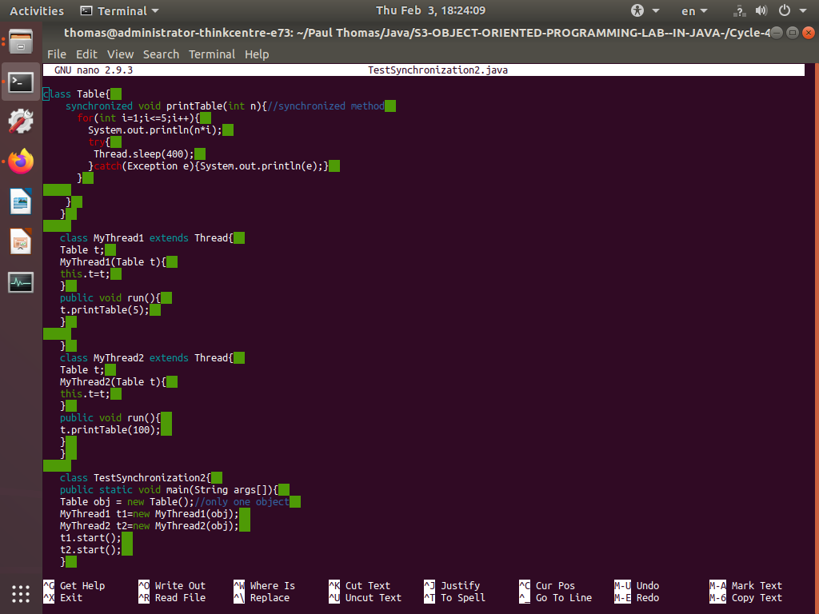

Output

